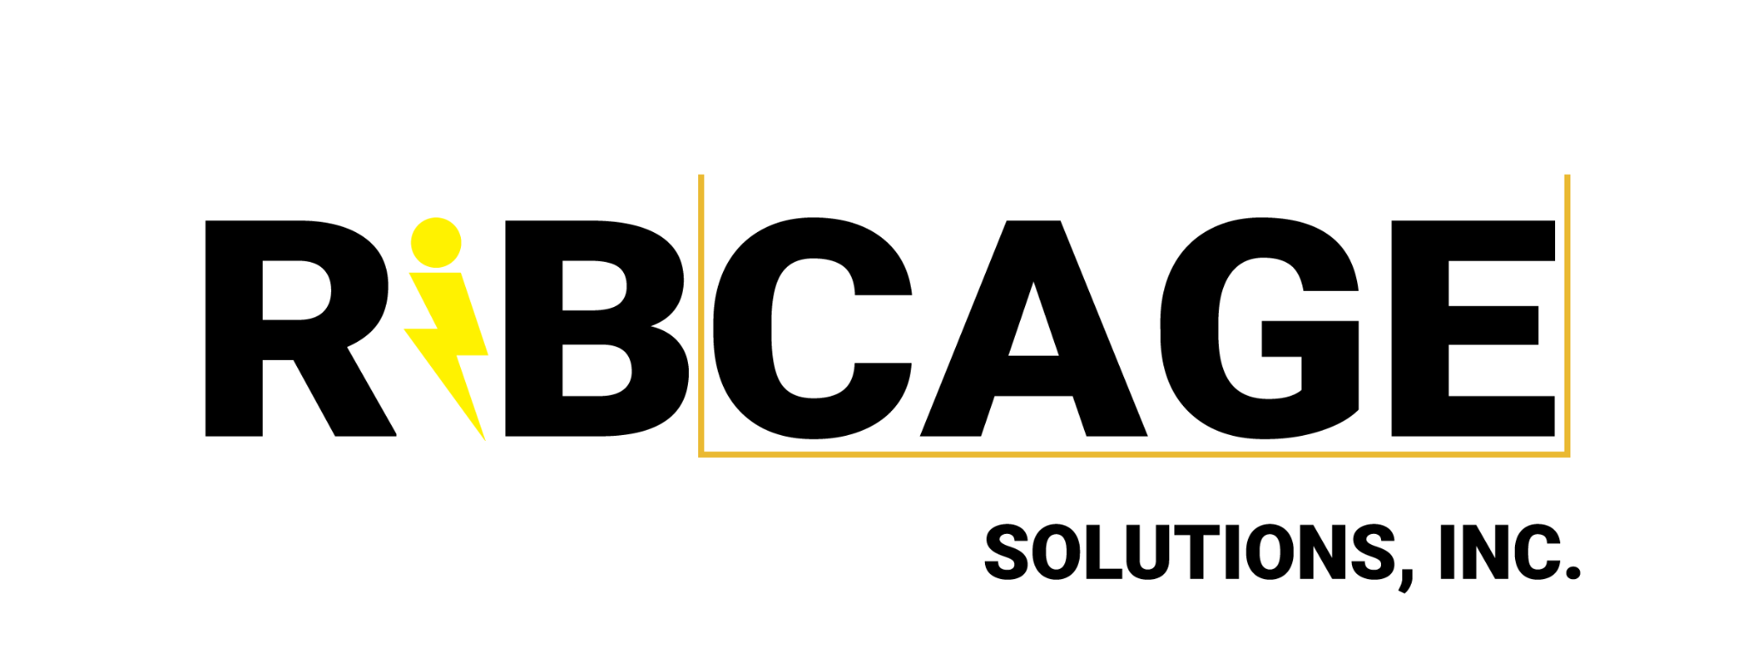

**ArcAngel Kit Safety Memo**

An ArcAngel Kit is installed around the perimeter of a towable generator to protect it from lightning strikes in the case of inclement weather.

If there is lightning, there will be a 30/30 call. During a 30/30 call, all crew must shelter indoors but protected generators will stay on and keep indoor equipment powered, enabling the unit to continue work on schedule.

ArcAngel kits are lightning protection systems. Do not touch an ArcAngel Kit for any reason, under any circumstances. Do not attempt to fix an ArcAngel kit should it be damaged.

If you see that a part of the kit has been damaged by a storm or otherwise, or if you think it has been disconnected or broken, DO NOT attempt to adjust or reconnect anything. If you notice anything you think is off, notify the AD department or safety so they can request help from the vendor.

Ribcage Solutions Inc.

info@ribacgesolutions.com | 470-600-CAGE